**Project Name:**

**CAR Rental Management System**

**Analysis and Design Phase**

**Project Participant: Taha Manshoor (23-NTU-CS-1213)**

**Submitted to: Sir Arsal Mahmood**

**Chapter One**

**Business Requirements and Rules**

**Users:**

* The system manages two types of users: administrators and customers.
* Administrators can add, update, and approve new customer registrations.

**Customers:**

* Customers can be registered in the system, providing their name, age, address, cell number, and VIP status (if applicable).
* Customers must be at least 18 years old to register.

**Vehicles:**

* The system supports two types of vehicles: cars and trucks.
* Each vehicle has a unique number plate, brand, model, price per rental, and additional properties:
  + Cars - number of passengers
  + Trucks - load capacity
* Vehicle prices must be greater than 0.
* Load capacity for trucks must be greater than 0.

**Rentals:**

* Customers can potentially rent vehicles.
* Rentals have a unique rental ID, rental date and a return date.

**Payments:**

* Customers make payments for rentals using a credit card.
* Payments have a unique identifier, card number, payment amount, and payment status.
* Payment amounts must be greater than 0.

**Business Rules:**

* Admins can sign up using a unique username and password, providing personal details such as name, email, address, and phone number.
* Admins can be approved by other admins, changing their active status from 0 to 1.
* Customers must be older than 18 years old to be added to the system.
* Customers can update their personal details such as age, VIP status, address, and contact information.
* Rentals are assigned unique rental IDs and include rental dates and return dates.
* Payments are associated with rentals, with unique payment IDs, payment amount, payment status, and card information.
* Customers can rent vehicles, with their rental details stored in the system.
* Cars and trucks can be updated with new details such as brand, model, price, and capacity.
* The system maintains views to display available cars and trucks for rental.

**List of Final Entities**

1. Admin

1. Customers
2. Rentals
3. Payments
4. Cars
5. Trucks

**List of Final Relationships**

* Admin **manages** Customers.
* Customers **rents** Cars/Trucks
* Payments **made by** Customers.
* Vehicles **rented by** Customers.
* Rentals **associated with** payments.

**EERD:**

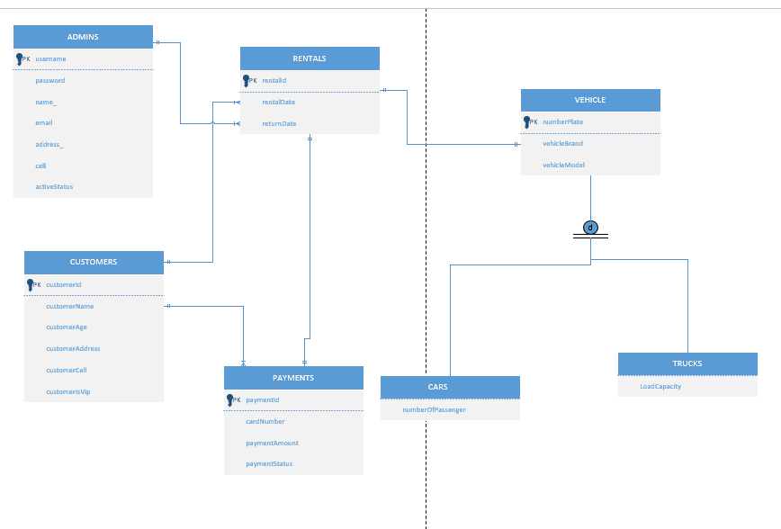

**Tables Converted from EERD:**

**ADMINS**

|  |  |  |  |  |  |  |
| --- | --- | --- | --- | --- | --- | --- |
| Username | password | name_ | email | address_ | cell | active Status |

**CUSTOMERS**

|  |  |  |  |  |  |
| --- | --- | --- | --- | --- | --- |
| customerId | customerName | customerAge | customerAddress | customerCell | customerIsVip |

**VEHICLES**

|  |  |  |  |
| --- | --- | --- | --- |
| numberPlate | vehicleBrand | vehicleModel | vehiclePrice |

**CARS**

|  |  |
| --- | --- |
| numberPlate | numberOfPassenger |

**TRUCKS**

|  |  |
| --- | --- |
| numberPlate | loadCapacity |

**PAYMENTS**

|  |  |  |  |  |  |
| --- | --- | --- | --- | --- | --- |
| paymentID | cardNumber | paymentAmount | paymentStatus | customerID |  |

**RENTALS**

|  |  |  |  |  |
| --- | --- | --- | --- | --- |
| rentalID | rentaldate | returndate | paymentID | customerID |

**Chapter Two**

**Tables After 3NF:**

**ADMINS**

|  |  |  |  |  |  |  |
| --- | --- | --- | --- | --- | --- | --- |
| Username | password | name_ | email | address_ | cell | active Status |

**CUSTOMERS**

|  |  |  |  |  |  |
| --- | --- | --- | --- | --- | --- |
| customerId | customerName | customerAge | customerAddress | customerCell | customerIsVip |

**VEHICLES**

|  |  |  |  |
| --- | --- | --- | --- |
| numberPlate | vehicleBrand | vehicleModel | vehiclePrice |

**CARS**

|  |  |
| --- | --- |
| numberPlate | numberOfPassenger |

**TRUCKS**

|  |  |
| --- | --- |
| numberPlate | loadCapacity |

**PAYMENTS**

|  |  |  |  |  |  |
| --- | --- | --- | --- | --- | --- |
| paymentID | cardNumber | paymentAmount | paymentStatus | customerID |  |

**RENTALS**

|  |  |  |  |  |
| --- | --- | --- | --- | --- |
| rentalID | rentaldate | returndate | paymentID | customerID |

**VEHICLE_RENT_CUSTOMER_PAYMENT**

|  |  |  |  |  |
| --- | --- | --- | --- | --- |
| customerid | rentalid | paymentid | rentstatus | numberplate |

**Forms and Forms Layout**

* Sign Up Form

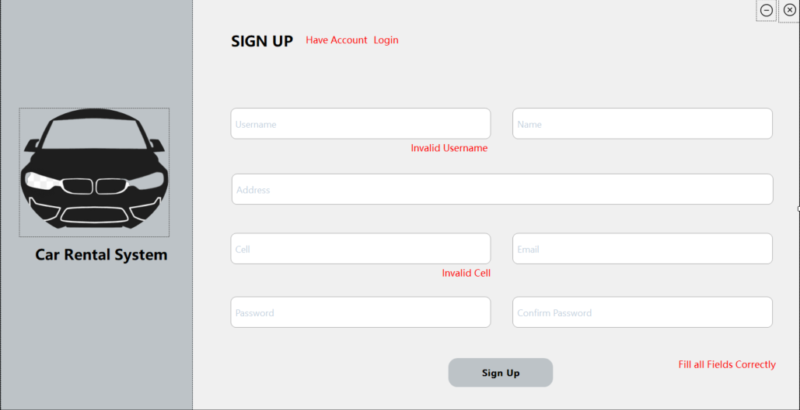

* Customers Form

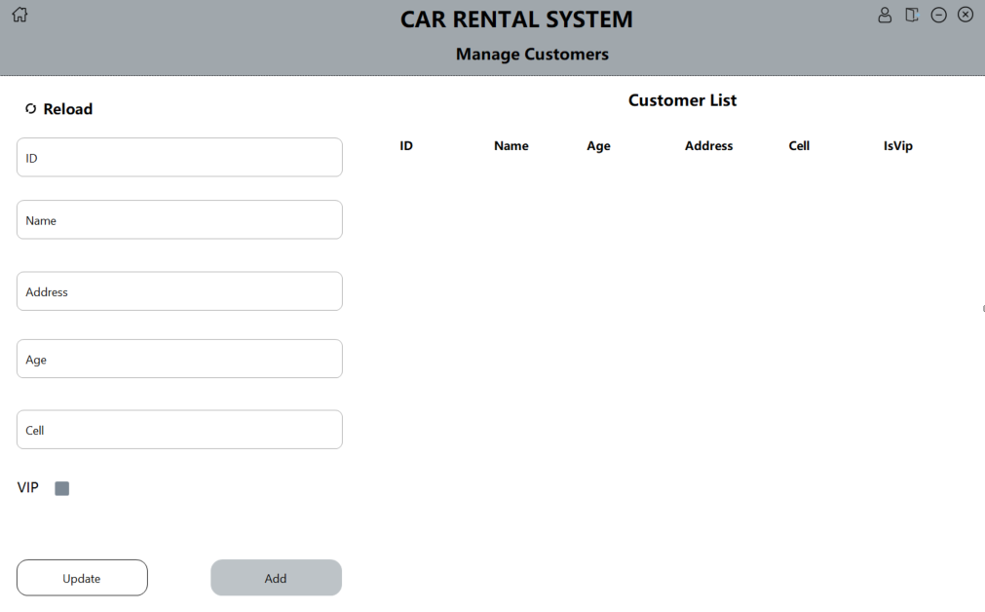

* Rentals Form

* Approve Admins Form

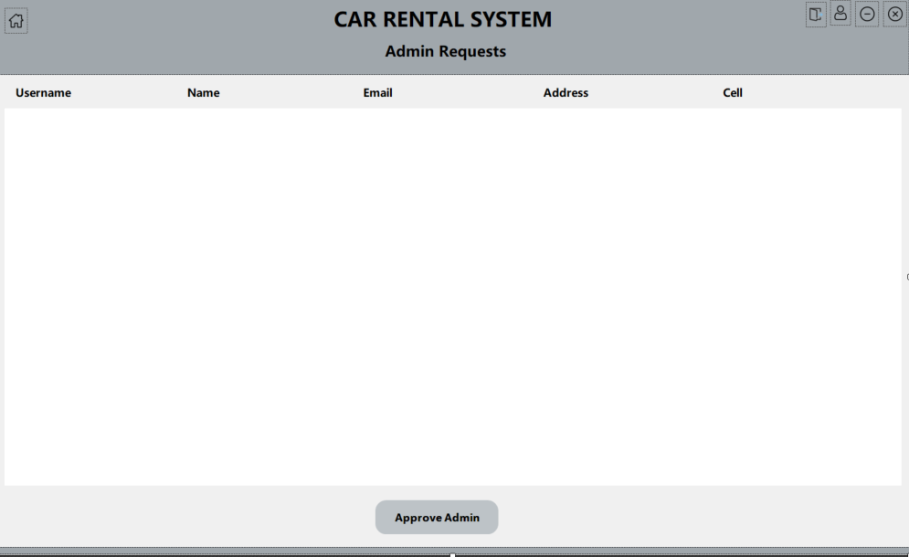

* Profile Form

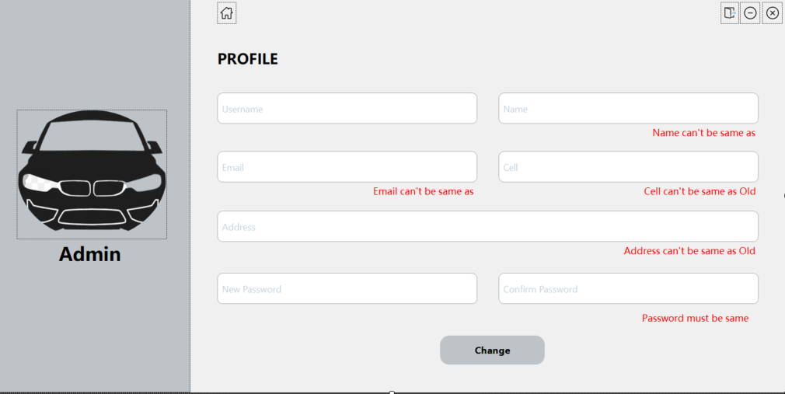

* Menu Form

* Vehicles Form

**Reports and Reports Layout**

* Report of Cars List.
* Report of Trucks List.
* Report for Admin for approving admins.
* Report for Customers List.
* Report to see the Vehicles on Rent.
* Report to see the vehicles available for rent.